# QUIZ - Single series

## Question 1

Below is a time series graph of visitors in New Zealand from the UK. Data has been collected for every quarter.

[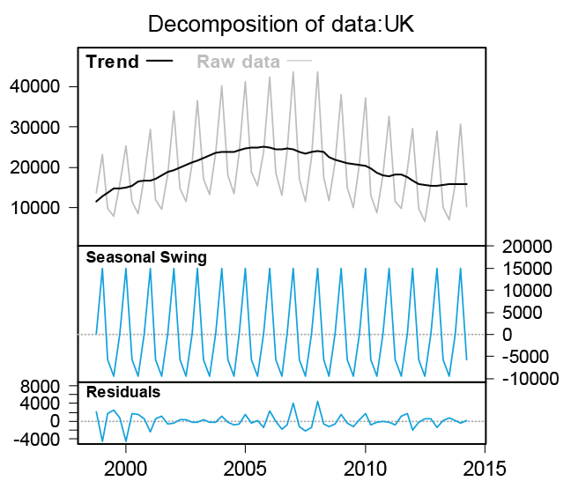](https://flexiblelearning.auckland.ac.nz/data-to-insight/9/1/images/quiz2b.png)  
Select the statement that is **FALSE**.

The trend curve is highest at about 2006 where, at the highest point, there were just over 40,000 visitors from the UK in New Zealand.

The saw-tooth patterns on the graph are the fluctuations in number of visitors due to seasonal variation.

**A series is only seasonal if the fluctuations occur on a yearly cycle.**

The decompostion has used an additive model with constant seasonal swings but the swings in the actual series in the top panel look smaller towards the ends and wider in the middle.

A multiplicative decomposition would probably work better for this series.

Correct

This statement is FALSE – Seasonality refers to a pattern that repeats over a regular or fixed time period. This time period does not have to be a year. It is often also a week or even a day.

## Question 2

Below is a seasonal plot for the average number of visitors from the UK in New Zealand in any given quarter.

[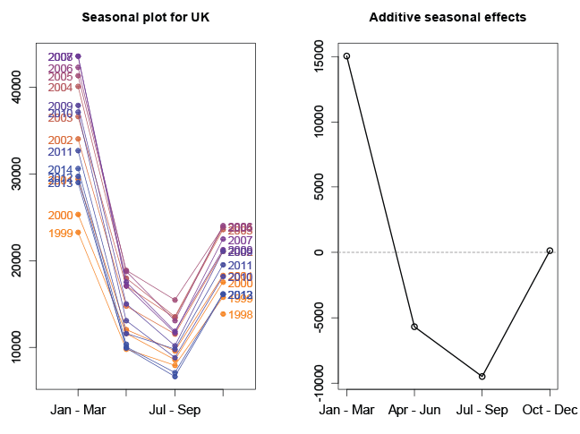](https://flexiblelearning.auckland.ac.nz/data-to-insight/9/1/images/quiz1b.png)

Assume for the purposes of this question that the average seasonal effects in the graph provide a reasonable summary of the behaviour of the series. Select the statement that is **FALSE**.

The right hand panel gives the average seasonal effects for each quarter.

The trend line would be about 15,000 below the Jan-Mar point.

July-Sep is the quarter with the lowest number of visitors and is usually about 9,000 below the trend line.

Values for the October-December quarter require no seasonal adjustment from the trend value.

**We’d expect there to be about 15,000 more visitors from the UK in Jan-Mar as there are in the April June quarter**.

**Correct**

This statement is **FALSE** – Jan-Mar is 15,000 people above the trend and Apr-Jun is about 6,000 below the trend line so the difference between the two seasons is about 21,000.